C183 Week 7 Lab
Cartographic Data
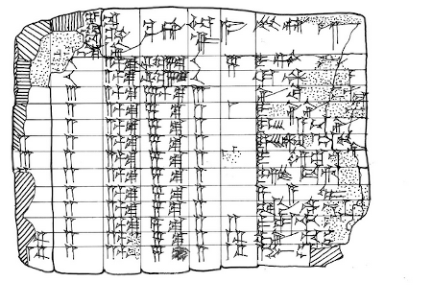

Babylonian Tabular Clay Tablet found near the Euphrates, 3600-4000 years ago

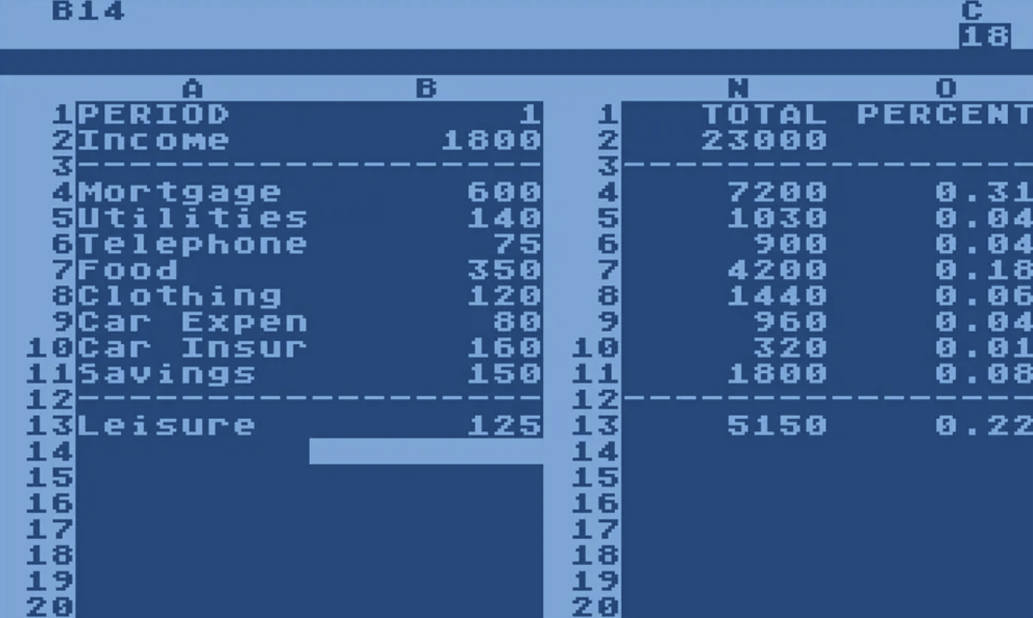

VisiCalc Interface, 1979

Lab Logistics and Deliverable
- Due October 7th, 11:59 PM
- Upload the three deliverables into one combined .pdf on bCourses
  - Completion of Data Portal(s) attribute table
  - Completion of Basemap layout using GIS graphic capabilities
  - Completion of Reflection on practice
0. Lab Seating Arrangement

Before settling into your desktop, please come to the front of the room and retrieve a sticky note. Please try to complete this pre-lab activity in 10 minutes or less so we don’t take time away from the lab activity!

The sticky notes are color coded on three scales: Green (I’ve done mapping before), Yellow (I’ve been exposed and working on my skills), Red/Pink (Help!!! I need to sit next to a green student in order to survive). Please be honest with yourself, this is meant to help us build a community of learning.

Additionally, write on the sticky note the niche skill you can bring to your new studio team (i.e. your row of four classmates). This can range from sound quantitative reasoning, appealing visual design, organized project management, etc.

Now that you have done self-assessment. Re-assign seating amongst yourselves to evenly distribute both skill level and niche assets. Please do not sit near your friend. Introduce yourself to someone new and do some personal growth.

These groups are not “locked” in place for the remainder of the semester. This exercise is meant to ensure come the project weeks (11-14), our lab community knows who to turn to for assistance or feedback. And, it is encouraged to keep working with new people of different skill levels and niche assets.

Foundations Pathway

Prompt

You work with a small team of cartographers within a larger graphic design studio based in California, Visit California reaches out to the firm and needs some travel reference print maps for analog distribution to complement the digital maps on their website. The Principal of Tourist Affairs says the maps can either be at the scale of a place of interest (i.e. Monterey Bay) in California, or a region of California (i.e. Napa Wine Country and Marin/Point Reyes Wilderness).

These maps are intended to be used by tourists who are moving around California in their automobiles. Their activities might consist of hiking, going to the beach, the mountains, visiting cities, wine tasting, witnessing a superbloom and much more.

In groups of 2-3 (or 4, if your whole row is doing the foundations pathway), browse through the preexisting digital maps and decide with your group which area of or place in California you want to map for Visit California’s publication.

NOTE: even if you are doing maps at the scale of a place or region. You will probably end up downloading data for the entire state. That is okay. For the foundation pathway, focus on practicing assessing the nature of your mapping project, and finding the appropriate datasets to represent the landscape in question. If you are feeling a little adventurous, you can begin to play around with some of the GIS data operations to clean your data (i.e. filtering, joins, clip). Only execute those functions if you are feeling comfortable.

Data Portal(s) and Acquisition

As I describe in the lab slides, a major component of the cartographic workflow is your ability to interpret the nature of a map request. Last week, your lab activity got you to practice the art of visualizing how you want the map to be drawn as an image before any data acquisition and manipulation work happens.

I am in the school of thought (and why this version of the Projection lab differs from a typical spatial analysis course) that the ability to envision what your project will look like in the end drives a lot of the decisions you make.

Now that you have that foundational ability to imagine the map you want to make, and properly troubleshoot GCS/PCS issues in your dataset, the next phase of any cartographic project is to translate the aforementioned prompt into a set of distinct GIS data layers (likely from different data sources) which can be analyzed and composed into an image.

Additionally, if your team is struggling to come up with potential data layers here are some ideas (thankfully, a region and state like California has lots of data!):
- transportation features (i.e., interstate, local roads, rails, trails, etc.)
- waterbodies (i.e.., lake or pond, reservoir, etc.)
- flowlines (i.e.., streams, artificial paths, etc.)
- political and administrative boundaries (i.e.., county limits, state parks, etc.)

Requirements for phase 1 of the activity
- Acquire 3-5 sources of GIS data
- Utilize 2-3 data portals (you’ll notice the USGS National Map has… everything. So make sure to expand your horizons!)
- Ensure you have one of each feature geometry for your data layers: Point, Line and Polygon
- Rename and order your layers in the Map Frame panel
- Utilize the data management attribute table as a guide

Data Attribute Table

GIS Data Type | Feature Geometry | Geographic Element Classified | Scale | GCS, PCS, Projection Properties | Source
Feature or Geodata | Point, Line, Polygon | Road, Park Boundary, City, State, etc. | Scale and extent the dataset is collected at | CRS properties the data was collected and stored in | Link to data source
Feature | Line | River | Regional Hydrological Basin | NAD83, UTM Zone 11N, Transverse Mercator | Nevada Bureau of Mines and Geology

Basemap Construction and GIS Data Styling

Now, you and your project team need to begin processing the raw data into some form of a presentable basemap for your client.

As your team is styling the basemap in ArcPro, inspect each of the data layers. Think critically about what the feature layer is representing in the landscape, and how best you can appropriately design the data. Additionally, keep the client and audience in mind. Who is using the map? And in what contexts would this map be used? (These questions will be explored more in-depth come the lab in week 8).

Learning to think through the nature of your data, and the purpose of the map, are the pragmatic constraints which drive a lot of design decisions. Ultimately, you want to think of these choices through the lens of Primary and Secondary data. Primary data is the figure, the data we need to emphasize on the map. Secondary data is the ground, the contextual basemap information which is a helpful, muted complement for the primary data.

Reference this map I made during undergrad for a similar lab assignment if you are totally lost on what to do next.

Requirements for phase 2 of the activity
- Use a styling technique to emphasize a visual difference in feature category (i.e. county boundary vs park boundary)
- Use a styling technique to emphasize a visual difference in feature order (i.e. local road vs interstate highway)
- Include a cartographic layout element(s): Legend, Title, North Arrow, Scale Bar, Projection, Data Sources, or any other element you find necessary! (reference the 3.1 slides if you need inspiration)
- Export the layout you and your team created as a .pdf
- Finish the lab by completing the reflection below. Remember to combine all three of your deliverables into a .pdf (understanding basic file management will get you promoted, I wish I was joking).
Reflection

- Provide a brief summary of your project team’s workflow. Focus on moments where your team needed to make a cartographic decision concerning either the data acquisition or the styling of the data in ArcPro. What was taken into account when making the decision, were the issues encountered reminiscent of any concepts from the lecture and/or reading?

- Elaborate on the phrase “problem of geography as a concept and its expression as a data type.” Were there moments during the data acquisition process where there was ambiguity between your understanding of what a landscape feature is versus its classification? How do you think these issues with data influence our ability to design maps?

